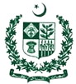
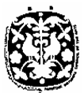
Pakistan National Council of the Arts

National Heritage & Culture Division

EXPRESSION OF INTEREST.

Expression of interest are invited to manage, operate and maintain a thematic Café at Pakistan National Council of the Arts, Islamabad. The Café is expected to cater to sophisticated tastes of Intellectuals, thinkers, Painters, diplomats and Pakistani clientele, in a serene and friendly ambiance.

EOIs alongwith documents establishing credible experience and financial standing must reach at address given below by 18.01.2022, for further detail please visit PNCA site.

Pakistan National Council of the Arts
Sector F-5/1, Islamabad
Ph:-051-9206227.

